Syllabus for the session 2024-25
Subject: English Std.: VIII
Name of the books:

- Fern’s English 8 – Literature
- Fern’s English 8 – Workbook
- P C Wren’s grammar 8

Month | Lesson/Chapter
April & May | Literature –  1.The Blue Light Grammar – Determiners Writing – Informal Letter Workbook – Worksheet 4
June | Literature –  - A Sea Of Foliage  Grammar – Verbs: Auxiliary and Modals Writing – Notice Writing, Diary Entry
July | Literature –  1. Maggie Cuts Her Hair  2. Be The Best Of What You Are(Poem)  Grammar –  - S-V agreement  - Tenses  Writing – Formal Letter (Letter to the editor) Workbook – Worksheet 9
Periodic Test - 1
August | Literature –  - My Financial Career  Grammar –  - Tenses(Contd..)  - Non-finites  Writing – Speech Workbook – Worksheet 8
September | Literature – The Rainy Day(Poem)  Grammar – Non-finites (Contd..)  Writing – Paragraph Writing  Workbook – Worksheet 1
Half Yearly Exam

October | Literature – The Sacred Tree  Grammar – 1.Modals  2.Conditionals  Writing – e-mail Writing  Workbook – Worksheet 7
November | Literature – Invictus(Poem)  Grammar – Voice Change  Writing – Story Development  Workbook – Worksheet 10
Periodic Test - 2
December | Literature –  - Cricket in the Road  Grammar – Prepositions  Writing – Advertisements Workbook – Worksheet 2
January | Literature –  Blow,Bugle,Blow(Poem)  Grammar – Reported Speech Writing – Dialogue Writing Workbook – Worksheet 6
February | Literature –  When You Can’t Climb Trees Anymore
Annual Exam

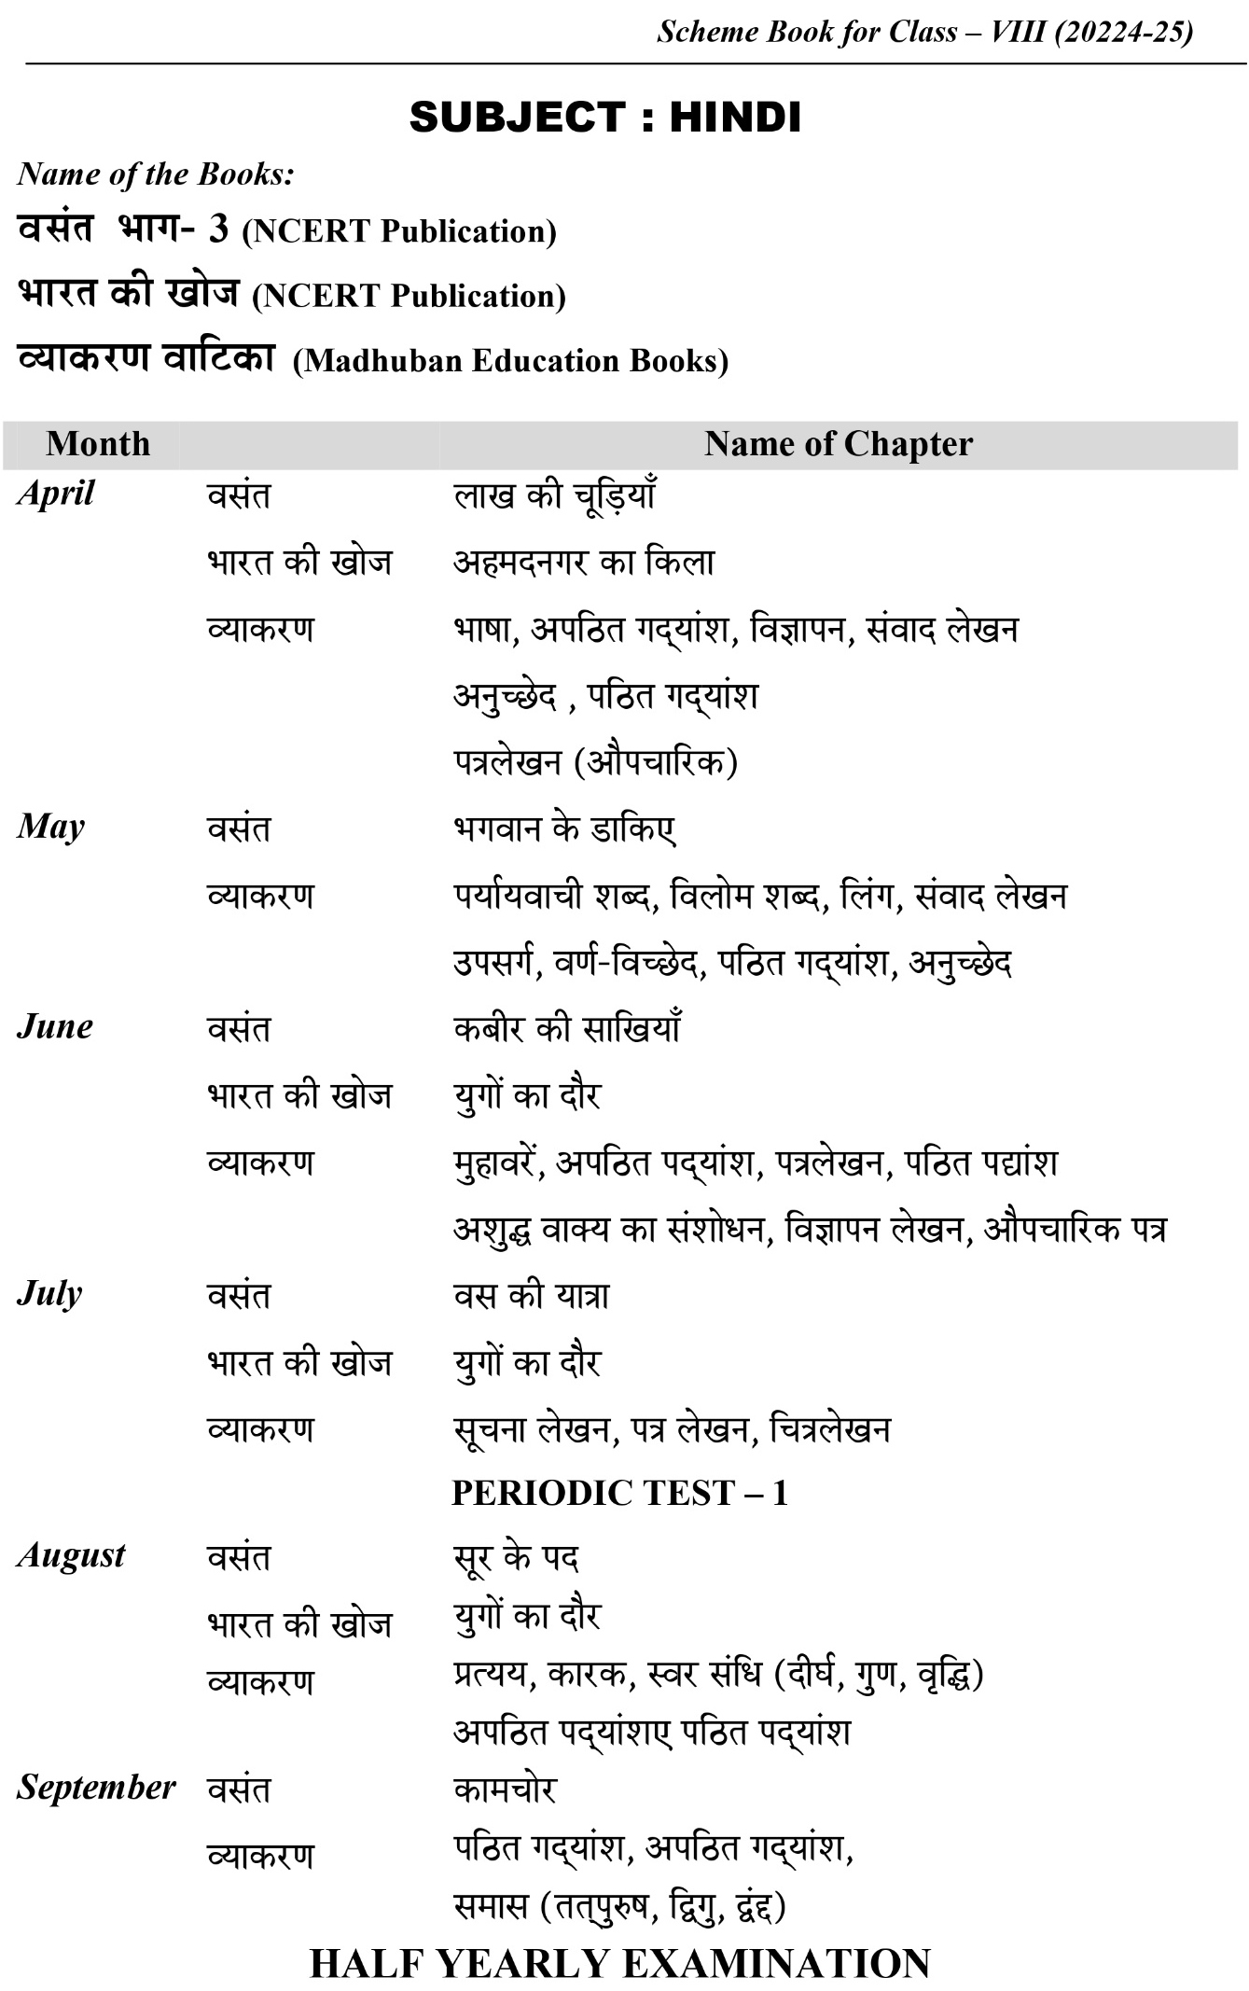
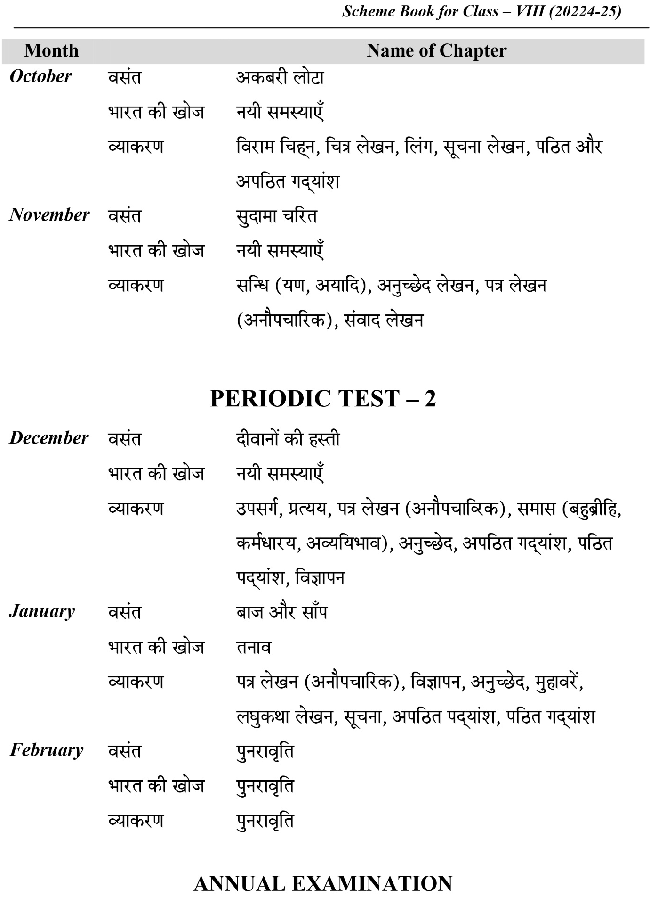

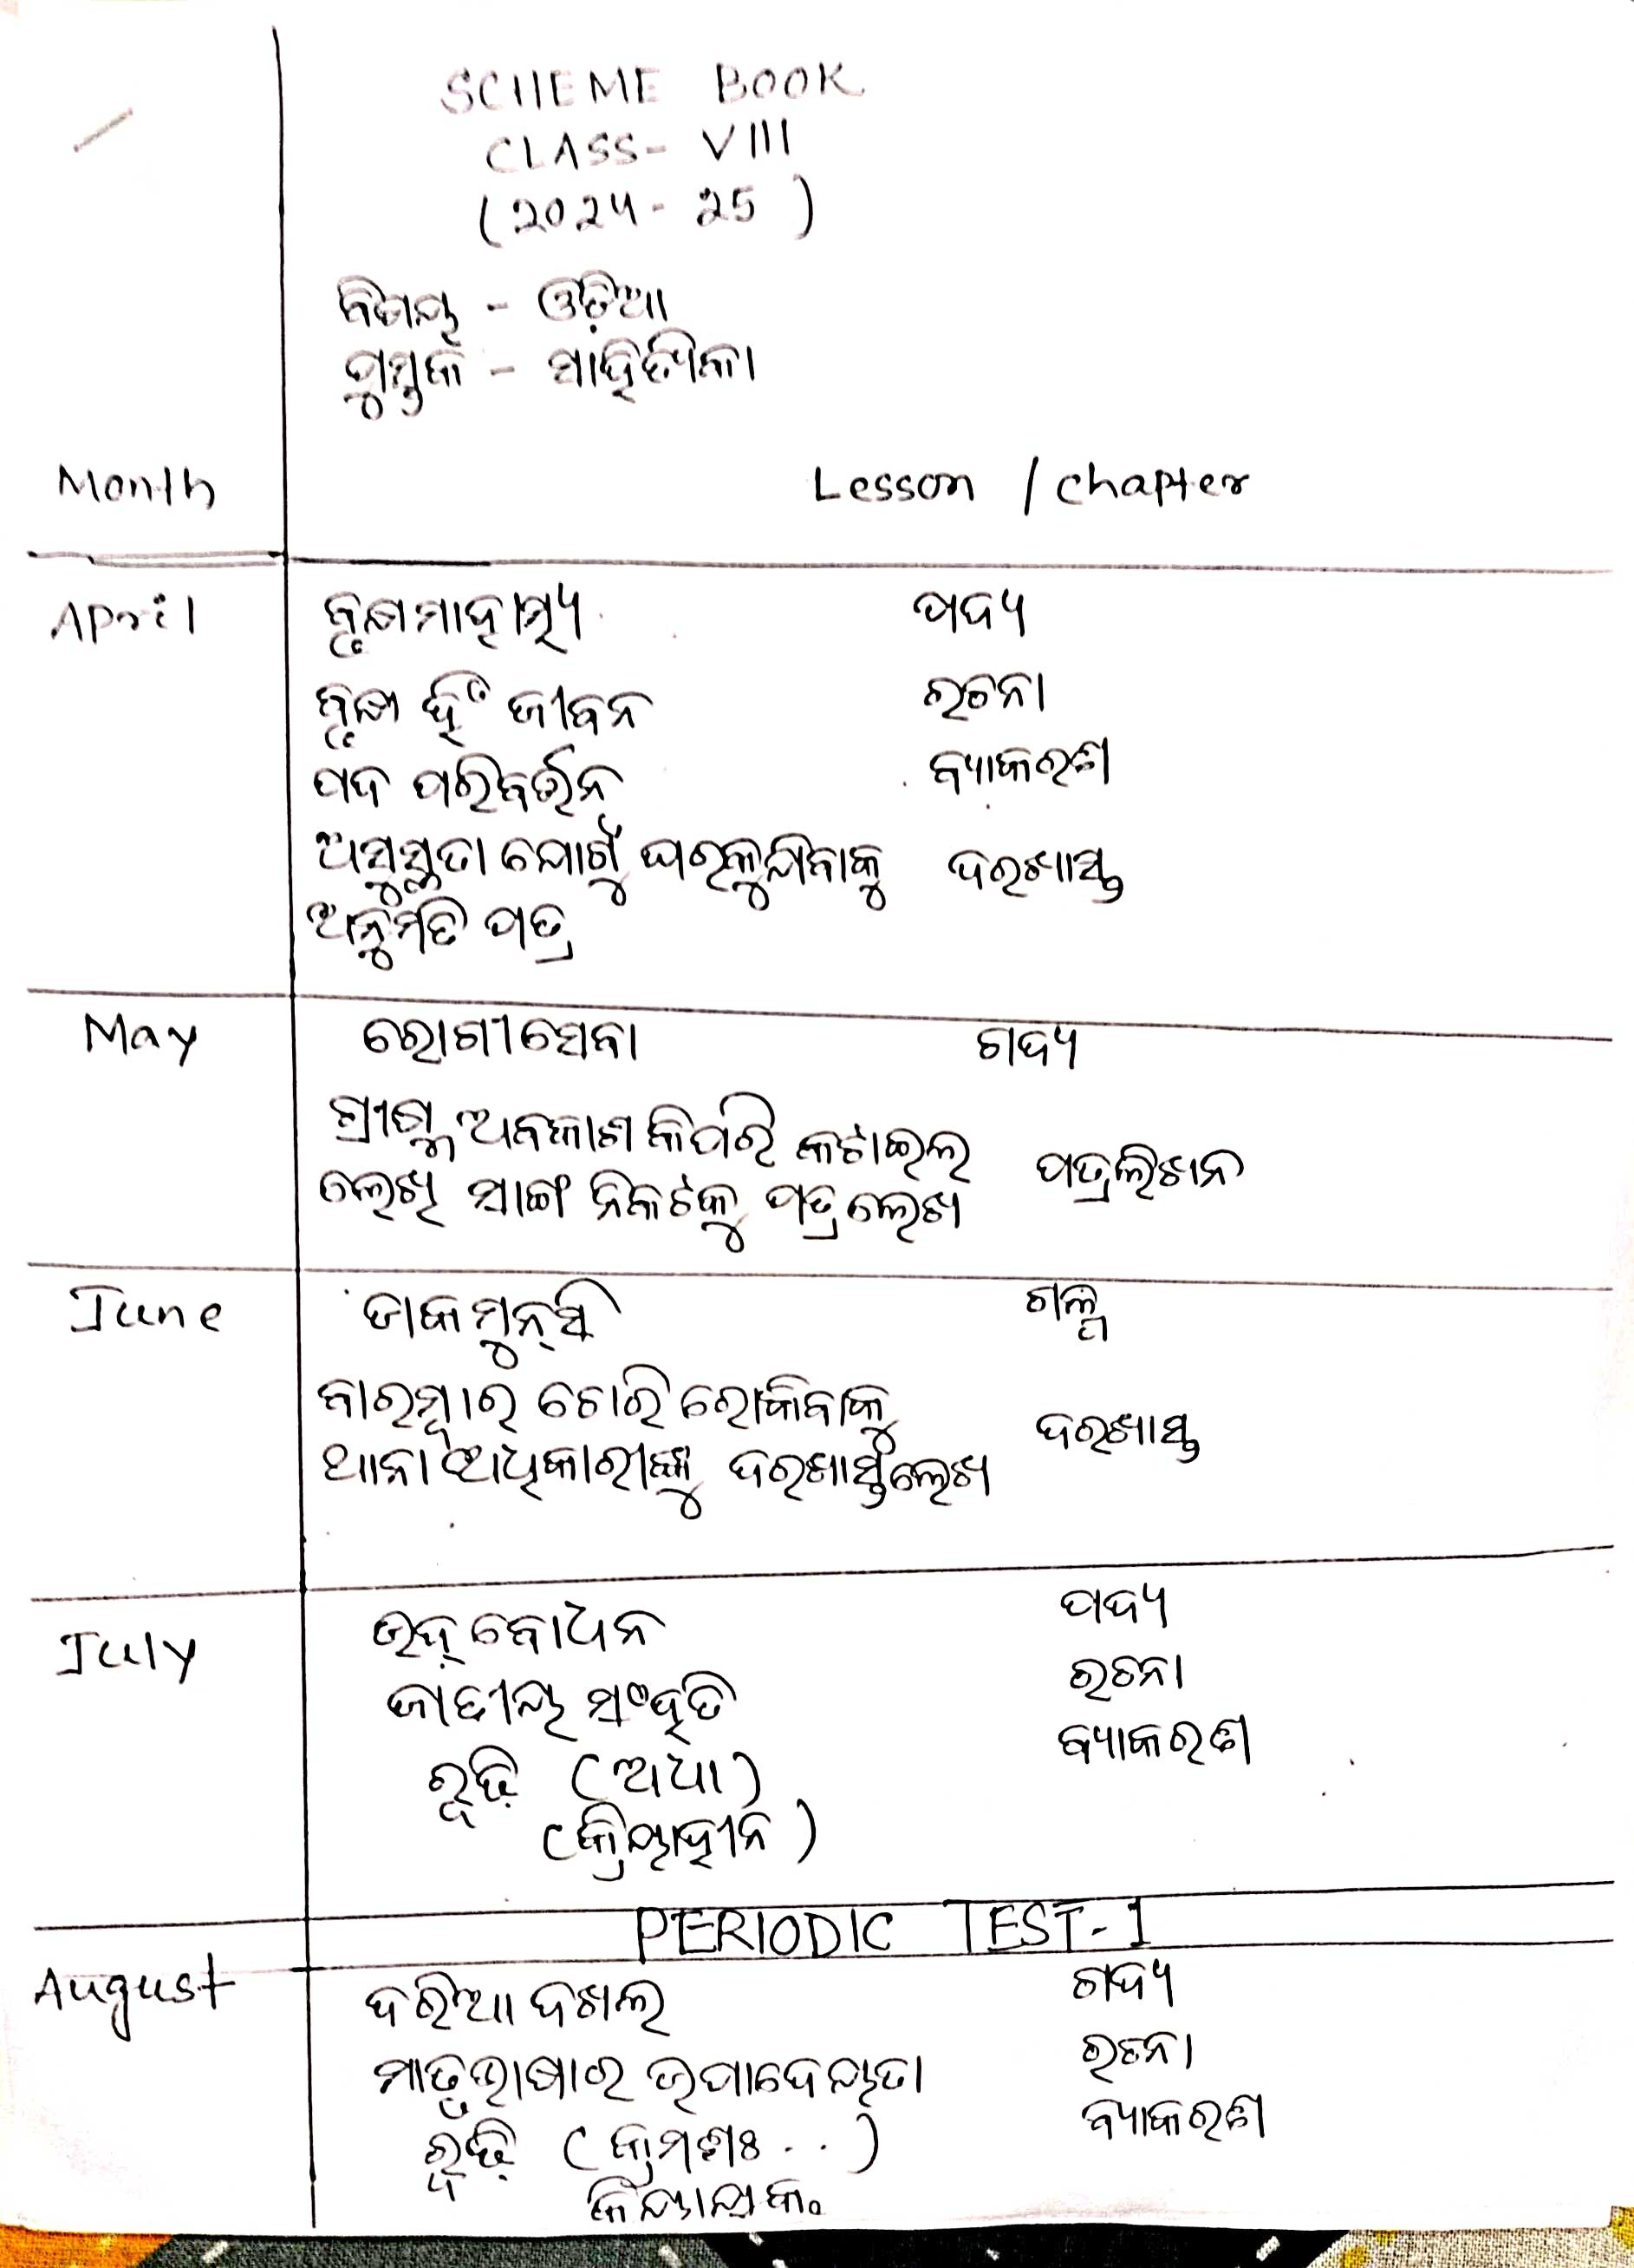

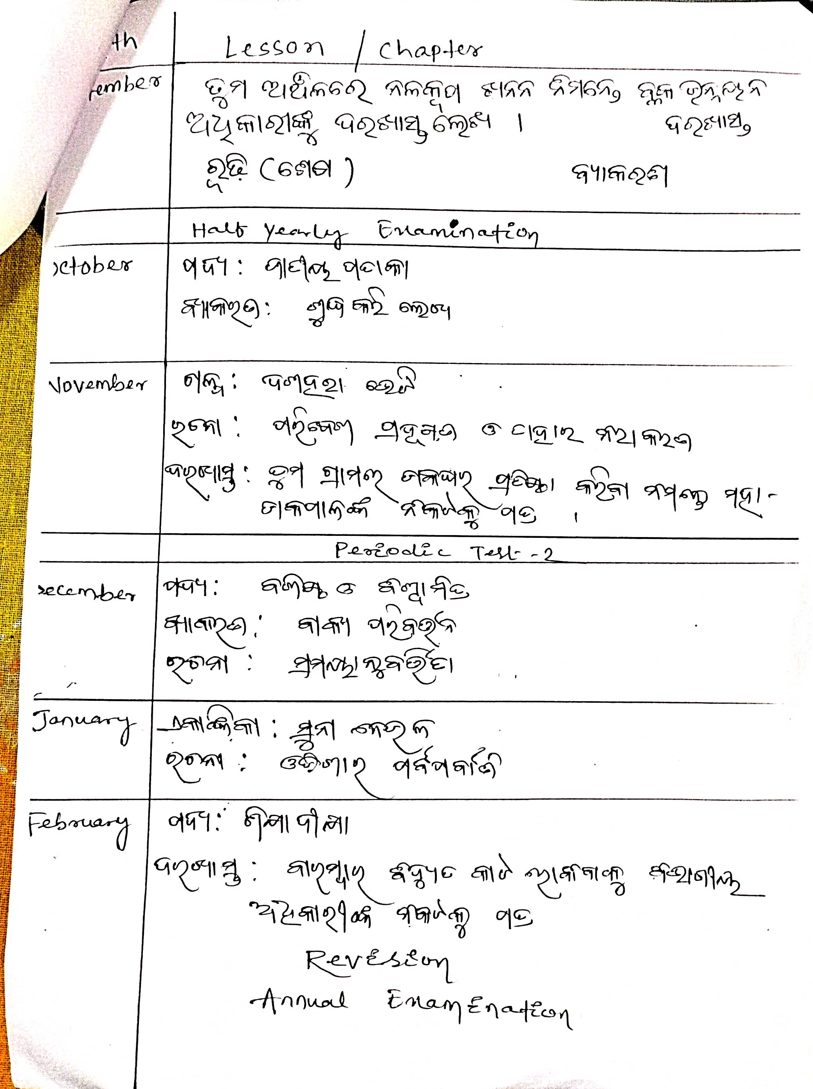

SUBJECT - MATHEMATICS
SYLLABUS FOR THE SESSION: 2024-2025
Name of the Books: Mathematics for Class- VIII,
Published by- NCERT New Delhi

Month | Chapter | Name of Chapter
APRIL | 1 | Rational Numbers
MAY | 2 | Linear Equation in One Variable
JUNE | 2 | Linear Equation in One Variable  (cont..)
JULY | 3 | PERIODIC TEST-1  Understanding Quadrilaterals
AUGUST | 3  5  6 | Understanding Quadrilaterals(cont...)  Squares and Square Roots  Cubes and Cube Roots
SEPT | 6  10  7 | Cubes and Cube Roots(cont..)  Exponents and Powers  HALFYEARLY EXAMINATION  Comparing Quantities
OCT | 7  8  9 | Comparing Quantities(Cont...)  Algebraic Expressions and Identities  Mensuration
NOV | 9  11 | Mensuration (cont...)  PERIODIC TEST- 2  Direct and Inverse Proportions
DEC | 11  12 | Direct and Inverse Proportions(cont..)  Factorisation
JAN | 12  4 | Factorisation(cont...)  Data Handling
Feb | 13 | Introduction to Graph  Revision
ANNUAL EXAMINATION

SYLLABUS FOR THE SESSION:2024-2025
CLASS- VIII
SUBJECT – PHYSICS
Name of the book: Science Text Book for Class VIII, NCERT Publication
Month | Chapter/Lesson
April | Chapter – 8 | Force And Pressure
May | Chapter – 8 | Force And Pressure (Contd.)
June | Chapter – 8 | Force And Pressure (Contd.)
July | Chapter – 8 | Force And Pressure (Contd.)
 |  | PERIODIC TEST - 1
August | Chapter – 9 | Friction
September | Chapter – 9 | Friction (Contd.)
 |  | HALF YEARLY EXAMINATION
October | Chapter – 10 | Sound
November | Chapter – 10  Chapter– 12 | Sound(Contd.)  Some Natural Phenomena
 |  | PERIODIC TEST - 2
December | Chapter– 12  Chapter– 13 | Some Natural Phenomena(Contd.)  Light
January | Chapter– 13 | Light (Contd.)
February | Chapter– 13 | Light (Contd.)  Revision work  ANNUAL EXAMINATION

SYLLABUS FOR THE SESSION: 2024-2025
CLASS-VIII
SUBJECT – CHEMISTRY
Name of the book: Science Text Book for Class VIII, NCERT Publication
Month | Chapter/Lesson
April | Chapter – 3 |  | Coal and Petroleum
May | Chapter – 3 |  | Coal and Petroleum (Contd.)
June | Chapter – 3 |  | Coal and Petroleum (Contd.)
July | Chapter – 3 |  | Coal and Petroleum (Contd.)
 |  |  | PERIODIC TEST - 1
August | Chapter – 4 |  | Combustion and Flame
September | Chapter – 4 |  | Combustion and Flame (Contd.)
 |  |  | HALF YEARLY EXAMINATION
October | Chapter – 4 |  | Combustion and Flame (Contd.)
November | Chapter – 4  Chapter – 11 |  | Combustion and Flame (Contd.)  Chemical effect of Electric Current
 |  |  | PERIODIC TEST - 2
December | Chapter – 11 |  | Chemical effect of Electric Current (Contd.)
January | Chapter – 11 |  | Chemical effect of Electric Current (Contd.)
February | Revision Work  ANNUAL EXAMINATION

SYLLABUS FOR THE SESSION: 2024-2025
CLASS-VIII
SUBJECT – BIOLOGY
Name of the book: Science Text Book for Class VIII, NCERT Publication
Month | Chapter/Lesson
April | Chapter – 1 | Crop Production And Management
May | Chapter – 1 | Crop Production And Management (Contd.)
June | Chapter – 1 | Crop Production And Management (Contd.)
July | Chapter – 1 Chapter– 2 | Crop Production And Management (Contd.)  Microorganisms : Friend and Foe
 |  | PERIODIC TEST - 1
August | Chapter– 2 | Microorganisms : Friend and Foe (Contd.)
September | Chapter– 2 | Microorganisms: Friend and Foe (Contd.)
 |  | HALF YEARLY EXAMINATION
October | Chapter– 2  Chapter– 5 | Microorganisms: Friend and Foe (Contd.)  Conservation of Plants and Animals
November | Chapter– 5 Chapter– 6 | Conservation of Plants and Animals(Contd.)  Reproduction in Animals
 |  | PERIODIC TEST - 2
December | Chapter– 6  Chapter– 7 | Reproduction in Animals  Reaching the Age of Adolescence
January | Chapter– 7 | Reaching the Age of Adolescence (Contd.)
February | Chapter– 7 | Reaching the Age of Adolescence (Contd.)  Revision work  ANNUAL EXAMINATION

SYLLABUS FOR THE SESSION-2023-24
CLASS-VIII
HISTORY AND CIVICS
Name of the books:
- Our pasts-iii
- Social and political life-iii

MONTH | CHAPTER | LESSON
APRIL | CIVICS-CH-1 | THE INDIAN CONSTITUTION
MAY | HISTORY-2 | FROM TRADE TO TERRITORY (CONT..)
JUNE | HISTORY-CH-2 | FROM TRADE TO TERRITORY
JULY | CIVICS-CH-2  HISTORY-CH-3 | UNDERSTANDING SECULARISM  RULING THE COUNTRYSIDE
PERIODIC TEST-1
AUGUST | HISTORY-CH-3  CIVICS-CH-3  HISTORY-CH-4 | RULING THE COUNTRYSIDE(CONT)  PARLIAMENT AND THE MAKING OF LAWS  TRIBALS,DIKUS AND VISION OF GOLDEN AGE
SEPT | HISTORY-CH-4 | TRIBAL,DIKUS,AND VISION OF GOLDEN AGE(CONT)
HALF YEARLY EXAM
OCT | HISTORY-CH-5  CIVICS-CH-4 | WHEN PEOPLE REBEL 1857 AND AFTER  JUDICIARY
NOV | CIVICS-CH-4  HISTORY-CH-6  CIVICS-CH-5 | JUDICIARY(CONT)  CIVILISING THE “NATIVE”, EDUCATING THE NATION  UNDERSTANDING MARGINALISATION
PERIODIC TEST-2
DEC | CIVICS-CH-6  HISTORY-CH-7 | CONFRONTING MARGINALISATION  WOMEN,CASTE AND REFORM
JAN | HISTORY-CH-7  CIVICS-CH-7  HISTORY-CH-8 | WOMEN, CASTE AND REFORM(CONT)  PUBLIC FACILITIES  THE MAKING OF THE NATIONAL MOVEMENT;1870S-1947
FEB | CIVICS-CH-8 | LAW AND SOCIAL JUSTICE(SUBJECT ENRICHMENT-OPEN BOOK TEST)  REVISION
ANNUAL EXAM

BUXI JAGABANDHU ENGLISH MEDIUM SCHOOL
COMPUTER SC. ANNUAL SCHEME SESSION : 2024-2025
CLASS –VIII

TERM | MONTH | CHAPTERS
TERM I | APRIL | - CONCEPT OF NETWORKING
TERM I | MAY | - CONCEPT OF NETWORKING (continued ….)
TERM I | JUNE | - CONCEPT OF NETWORKING (continued ….)  - USING LISTS IN HTML (PRACTICAL)
TERM I | JULY | - INTERNET APPLICATIONS  - USING TABLES IN HTML (PRACTICAL)
TERM I | AUGUST | - CLOUD COMPUTING  - APP DEVELOPMENT  - USING IMAGES& LINKS IN HTML (PRACTICAL)
TERM I | SEPTEMBER | - APP DEVELOPMENT (continued….)  - USING FRAMES IN HTML (PRACTICAL)
TERM II | OCTOBER | - CONTROL STATEMENTS IN PYTHON
TERM II | NOVEMBER | - CONTROL STATEMENTS IN PYTHON (continued….)  - STRING IN PYTHON
TERM II | DECEMBER | - STRING IN PYTHON (continued….)
TERM II | JANUARY | - ARTIFICIAL INTELLIGENCE
TERM II | FEBRUARY | - ARTIFICIAL INTELLIGENCE (continued….)  - LATEST TECHNOLOGY

BUXI JAGABANDHU ENGLISH MEDIUM SCHOOL
SCHEME BOOK – 2024-25
NAME OF THE BOOK- RESOURCE AND DEVELPOMENT
STD- VIII

MONTH CHAPTERo LESSION/TOPIC

APRIL CHAPTER:1 RESOURCES

MAY CAHPTER:1 RESOURCES (Cont…)

JUNE CHAPTER:2 LAND, SOIL, WATER, NATURAL VEGETATION AND WILDLIFE.

JULY CHAPTER:2 LAND, SOIL, WATER, NATURAL VEGETATION AND WILDLIFE RESOURCES .(Cont…)

July : Periodic Test – 1

AUGUST CHAPTER-3 AGRICULTURE

SEPTEMBER CHAPTER-3 AGRICULTURE(Cont…)

September : Half Yearly

OCTOBER CHAPTER-4 INDUSTRIES

NOVEMBER CHAPTER- 4 INDUSTRIES ( Cont…)

November:- Periodic Test – 2

DECEMBER CHAPTER-5 HUMAN RESOURCES .

JANUARY CHAPTER-5 HUMAN RESOURCES.(Cont…)

FEBRUARY REVISION REVISION

Annual Examination

